**Report**

**Total Employee**

SELECT COUNT(Employee_ID) AS Total_Employees

FROM [hr_employee_ dataset]



**Gender Distribution**

SELECT Gender,

COUNT(Employee_ID) AS Count,

ROUND(COUNT(Employee_ID) * 100.0 / SUM(COUNT(Employee_ID)) OVER (), 2) AS Percentage

FROM [hr_employee_ dataset]

GROUP BY Gender

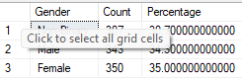

**Average Performance Score**

SELECT AVG(Performance_Score) AS Avg_Performance_Score

FROM [hr_employee_ dataset]



**Performance by Department**

SELECT Department, AVG(Performance_Score) AS Avg_Performance_Score

FROM [hr_employee_ dataset]

GROUP BY Department

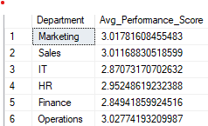

**Average Salary**

SELECT AVG(Salary) AS Avg_Salary FROM [hr_employee_ dataset]



**Salary by Department**

SELECT Department, AVG(Salary) AS Avg_Salary

FROM [hr_employee_ dataset]

GROUP BY Department

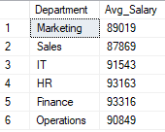

**Total Bonus Paid**

SELECT SUM(Bonus) AS Total_Bonus_Paid FROM [hr_employee_ dataset]



**Average Tenure (in Years)**

SELECT AVG(Tenure_Years) AS Avg_Tenure FROM [hr_employee_ dataset]



**Status Breakdown (Active, Terminated, On Leave)**

SELECT Status, COUNT(Employee_ID) AS Count

FROM [hr_employee_ dataset]

GROUP BY Status;

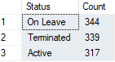

**Tenure distribution**

* SELECT CASE

WHEN Tenure_Years BETWEEN 0 AND 2 THEN '0-2 Years'

WHEN Tenure_Years BETWEEN 3 AND 5 THEN '3-5 Years'

WHEN Tenure_Years BETWEEN 6 AND 8 THEN '6-8 Years'

ELSE '9+ Years'

END AS Tenure_Group,

COUNT(*) AS Count

FROM [hr_employee_ dataset]

GROUP BY Tenure_Years

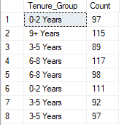

**New Hires by year**

SELECT YEAR(Hire_Date) AS Hire_Year, COUNT(Employee_ID) AS New_Hires

FROM [hr_employee_ dataset]

GROUP BY YEAR(Hire_Date)

ORDER BY Hire_Year;

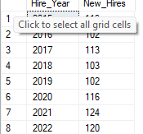

**Bonus Allocated by Department**

SELECT Department, SUM(Bonus) AS Total_Bonus

FROM [hr_employee_ dataset]

GROUP BY Department;

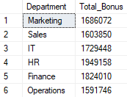

**Gender Py Gap Analysis**

SELECT Gender, AVG(Salary) AS Avg_Salary

FROM [hr_employee_ dataset]

GROUP BY Gender;

